**Build a schedule with 10 user entries:**

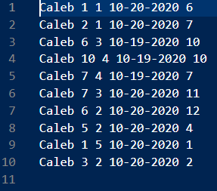User built schedule with 10 entries using the project code.

**Include test cases to verify that the user can print their schedule for several different trips per requirement f:**

Displaying vans on October 19th 2020. Displaying vans on October 20th 2020.

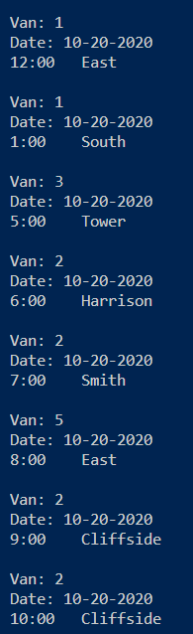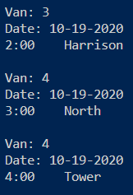

**Include test cases to verify that the user can list van schedules for all vans and for 1 van per requirement e.**

Displaying van schedules between 6 and 12.

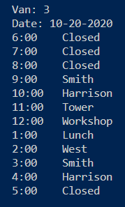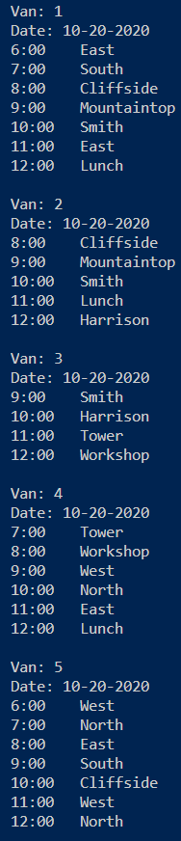Displaying van 3’s schedule between 6 and 5.

**Include a test case to verify a user can’t schedule a van outside of posted hours.**

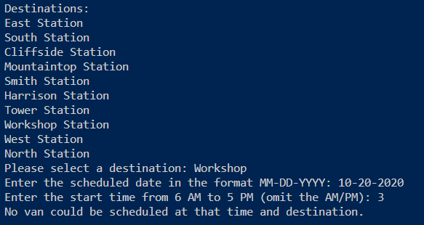

A failed attempt to schedule a van going to Workshop Station at 3:00, and an error message being given accordingly.

**Include a test case to verify a user can’t schedule a van if a van is busy.**

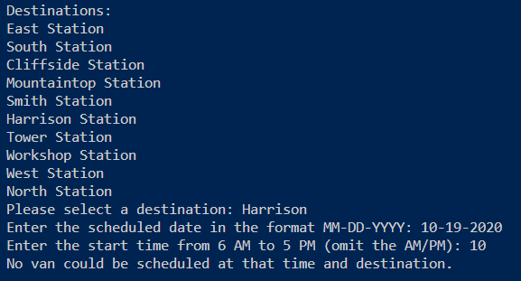

The topmost image is an output scheduling for Van 3 to arrive at Harrison station at 10 am on the 19th. When the user attempts to reschedule at the same time, the program detects this and errors, as shown in the bottom image.